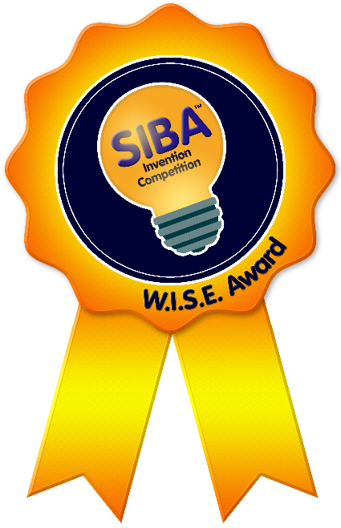
Student Ideas for a Better America™

Do you have a great idea?
…Or a better way to do something?

WANTED: YOUR IDEAS!
The National Museum of Education is looking for creative students in grades PreK-12+ College who are US students. Enter any idea or invention for a new way to demonstrate an educational concept, an idea for a new product, an improvement for an existing product, a new procedure, or any idea that solves a problem and/or makes life better. This can be simply an idea that is explained and described, an invention that is a prototype, an invention from a school project, or a project from another competition. All ideas are encouraged and a model is not required.

MISSION STATEMENT
Student Ideas for a Better America™ seeks to encourage the learning, insight, creativity, and workmanship of America’s students by recognizing and rewarding their accomplishments.
With grateful and loving honor, we announce the new "W.I.S.E. Award" in the Student Ideas for a Better America™ program: "Frances O. Williamson Inventions in Science Education".
For over 25 years, Frances O. Williamson was a science teacher and a pillar of the educational community. Her skilled, passionate and creative teaching introduced landmark projects to the science curriculum. Providing opportunities for students to race solar cars, launch rocket ships, and design maglev trains, Frances Williamson prioritized hands-on learning, interdisciplinary cooperation, and student creativity.
One ninth-grade class dedicated their yearbook to Mrs. Williamson: “She is not only a teacher, but also an advisor, friend and role model to all of us. She is imaginative and enthusiastic in and out of the classroom. She reminds us of the one and only Miss Frizzle from ‘The Magic School Bus’ leading into each [new]…adventure.”
The Student Ideas for a Better America™ award honors students who have embraced opportunities for inquiry, investigation and imagination that Mrs. Williamson fostered in generations of students.

GOALS
- To demonstrate that valuable ideas can be created by America’s youth.
- To encourage students to develop their ideas into reality.
- To move students from passive spectators to active participants.
- To ignite the faith that students can solve real-world problems.
- To inspire student pride in learning.
- To inspire America’s pride in her students.

WINNERS
Beginning September 2010, up to three winners are chosen each month and each will receive $100 and a certificate for his/her idea.

JUDGING CRITERIA & DIVISIONS
Entries are judged on creativity, uniqueness and usefulness. The judging takes into consideration the student’s age. There are three divisions: Grades PreK-3, Grades 4-8, and Grades 9-12+College

PRIVACY & OWNERSHIP
The National Museum of Education, Inc. is granted permission to use the entrant’s name, photograph, likeness, and entry materials including the design, prototype, and inventions for publicity purposes. Students retain ownership and all rights to the design, prototype and inventions.

ADDITIONAL BENEFITS
Winning entries are eligible for induction into the National Gallery for America’s Young Inventors. Six student inventors are inducted annually into the National Gallery, the museum where “Dreams Never Die”. Educational inventions may receive royalties, as seen on CNN and CBS, and may also be featured in highly circulated national science catalogs.

NATIONAL MUSEUM OF EDUCATION, INC.
The National Museum of Education is a non-profit organization developed and run by award-winning educators in conjunction with successful business people. It involves all grade levels, all types of students, and all subject areas. The Museum administers many national programs and its ultimate goal is to involve students everywhere in the innovative and creative process.

HOW TO SUBMIT IDEAS
- Student must be a US citizen
- Complete the submission form. Incomplete submissions will not be considered.
- Complete the questions describing your idea/invention fully. Attach additional pages, if necessary. (Please note: there are three applications available, one for each grade level division.)
- Include labeled and colored drawings, diagrams, etc.
- Consider an optional photo or video.

SENDING YOUR APPLICATION
- There is an online application for Grades 9-12+College available on www.nmoe.org
- You may also mail all application pages through USPS STANDARD MAIL ONLY to:
National Museum of Education, Inc.
4301 Darrow Road, Suite 3200
Stow, OH 44224
** Submissions requiring signature upon receipt WILL NOT BE ACCEPTED.

FOR MORE INFORMATION
Website: www.nmoe.org (Click on “Programs” … and then “Student Ideas for a Better America™”)
Email: info@nmoe.org
Phone: 234-900-6018

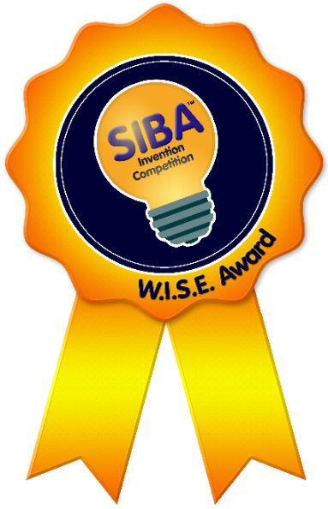
Student Ideas for a Better America™

HOW TO SUBMIT IDEAS
- Student must be a US citizen
- Complete the submission form. Incomplete submissions will not be considered.
- Complete the questions describing your idea/invention fully. Attach additional pages, if necessary. (Please note: there are three applications available, one for each grade level division.)
- Include labeled and colored drawings, diagrams, etc.
- Consider an optional photo or video.
For Internal Use Only

Received:
Reviewed:
Awarded:
Posted to web:
Filed:

SENDING YOUR APPLICATION
- There is an online application available on www.nmoe.org
- You may also mail all 3 pages through USPS STANDARD MAIL ONLY to:
National Museum of Education, Inc. | 4301 Darrow Road, Suite 3200 | Stow, OH 44224
** Submissions requiring signature upon receipt WILL NOT BE ACCEPTED.

SUBMISSION FORM – Grades 4-8
I. Student Information
First Name Last Name DOB (M/D/Y) Grade
Street Address City State Zip Code
Phone Email
II. School Information
School Name
Street Address City State Zip Code
Teacher/Mentor First Name Last Name Phone Email
III. Method of Contact if selected to win (Must Check One)
- Student Home
- School, care of Teacher/Mentor
IV. Invention/Idea Information (Type or write clearly)
Invention Name:
Invention name is original and not used for another product/service? (You can try Google searching your invention’s name to see if there is anything like it.) Yes No
If “YES”, describe WHAT your invention or idea is:

Explain HOW it works:

Is it an improvement upon an existing invention? Yes ____________ No
If “YES”, NAME the existing invention you are improving:
List materials needed to make your invention:

Include a drawing, photo and/or upload a video to YouTube. Provide YouTube video link below (*items will NOT be returned):
Were you able to create your invention? Yes _____________ No
If “YES”, how well did it work?

If your invention did NOT work well, what improvements are necessary?

V. Resources (you may leave blank if no resources were used):
- If you received help answering these questions and/or building your invention, list who helped.
- If you used any references (books, articles, online sources, etc.) list them below.

VI. Submission Checklist
- I have completed ALL information in sections I-V legibly, using complete sentences and in my own words.
- I have included photos, drawings, and/or the YouTube link to my video.
- I am using USPS Standard Mail to submit my form (or online), so no signatures are required upon receipt.
VII. Signature
Student Signature Date
Parent Signature (if student is under 18) Date
Teacher/Mentor Signature Date

